**WEEK - 1**

1. Create a database “Student” with the following attributes Rollno, Age, ContactNo, Email-Id.



1. Insert appropriate values

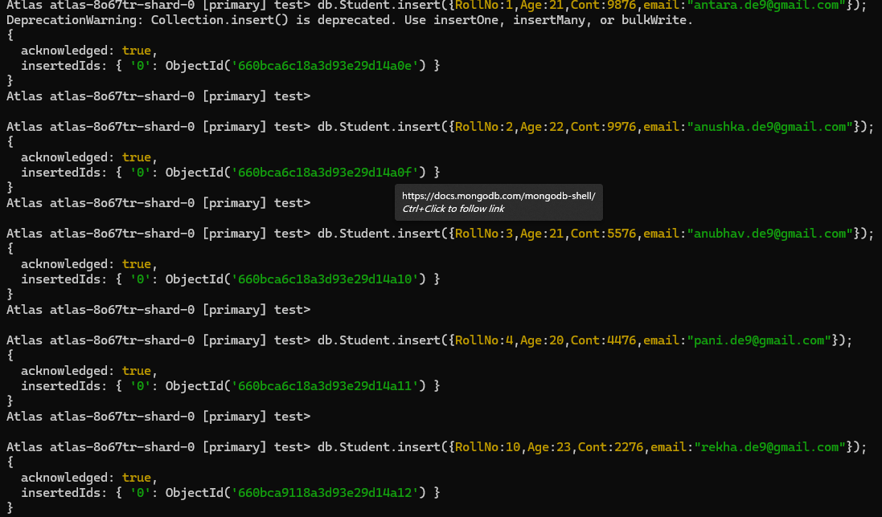

1. Write query to update Email-Id of a student with rollno 10.

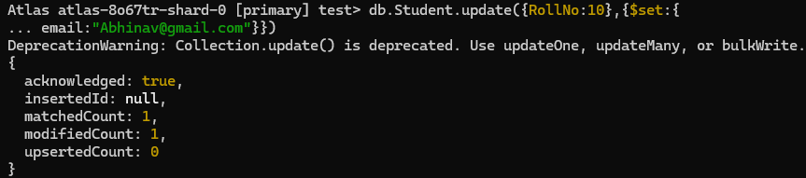

1. Replace the student name from “ABC” to “FEM” of rollno 11

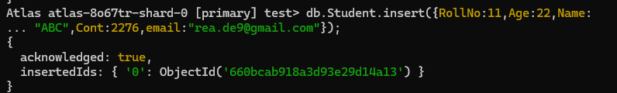

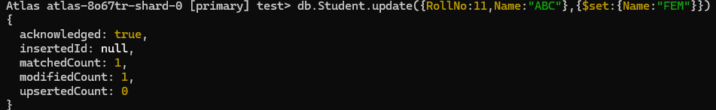

1. Display Student Name and grade(Add if grade is not present)where the _id column is 1.





1. Update to add hobbies

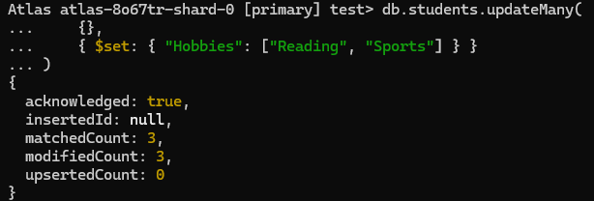

1. Find documents where hobbies is set neither to Chess nor to Skating

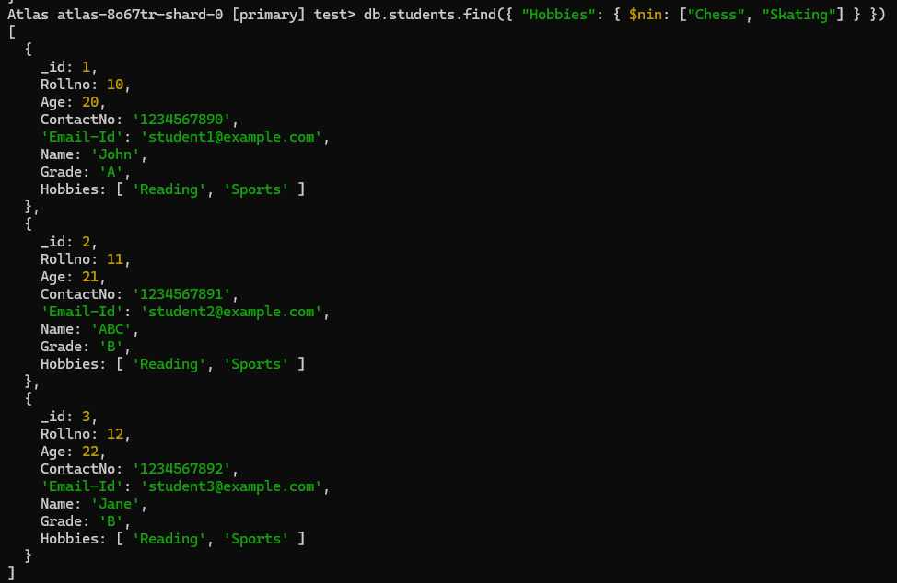

1. Find documents whose name begins with A

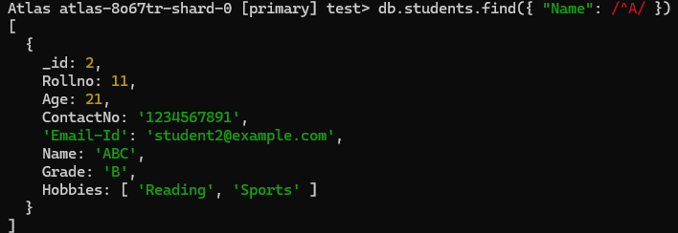

**WEEK - 2**

1. Create a collection by name Customers with the following attributes.

Cust_id, Acc_Bal, Acc_Type



2. Insert at least 5 values into the table

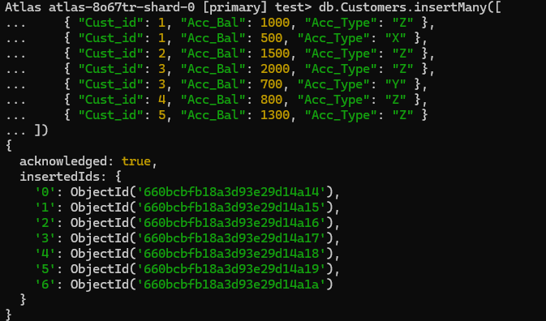

3. Write a query to display those records whose total account balance is greater than

1200 of account type ‘Z’ for each customer_id.

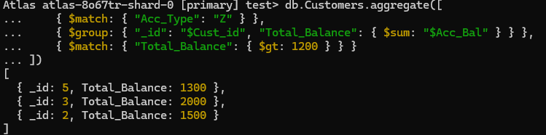

4. Determine Minimum and Maximum account balance for each customer

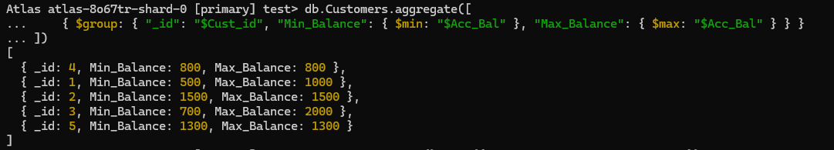

5. Sort the documents based on Customer ID in ascending order and Account Balance in descending order

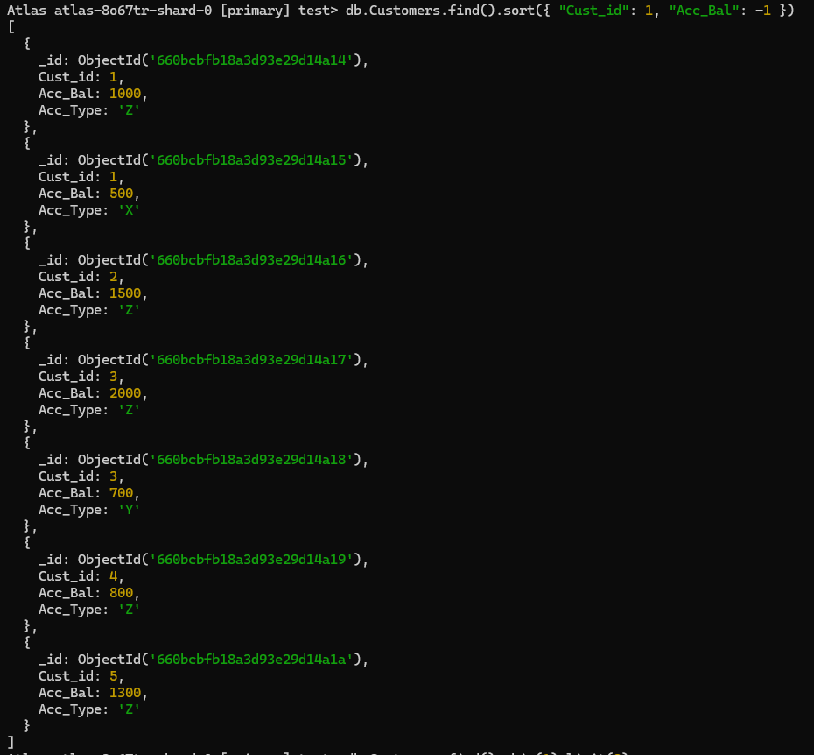

6. Display only 2 nd and 3 rd records from the collection

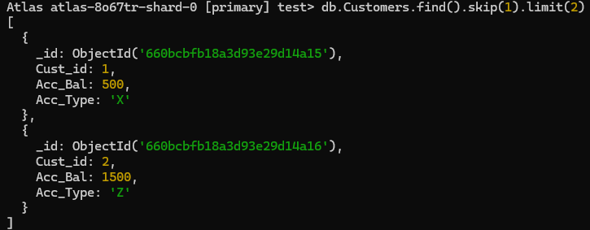

**WEEK-3**

Create a collection by the name blogPosts and it has 3 fields id, title and comments.

In the collection the comments field is an array which consists of user details. Each collection

consists of two user details inside the comments array- user name and text

Demonstrate the following

1. Creating 2 collections

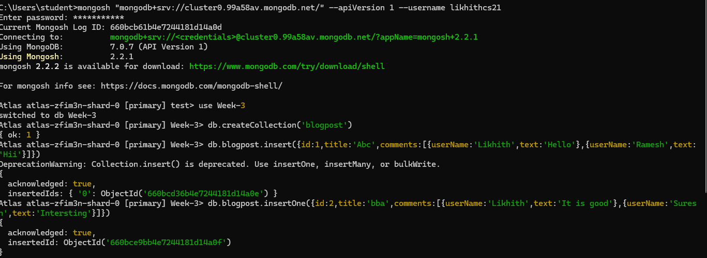

2. Display second element (id = 2)

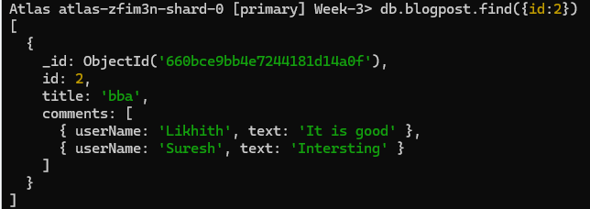

3 .Display size of the array



4. Display first two elements of the array

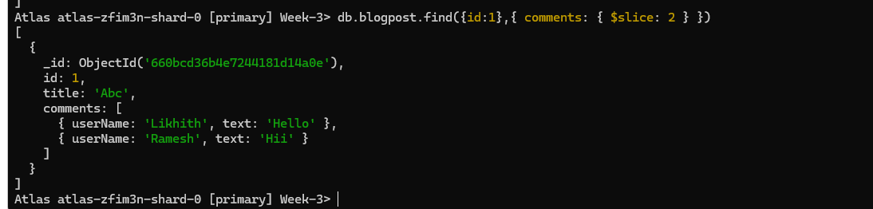

5. Update the document with id 4 and replace the element present in 1st index position of the

array with another array

